Step-by-Step Instructions to Create a FrontDesk Account
- Click Create Now below the login button to begin your account creation.
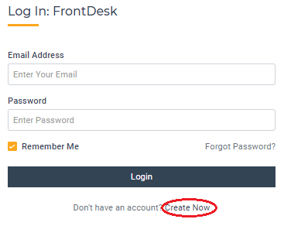
Are you a current Utility customer receiving bills? If so, select Yes. If not, select No.
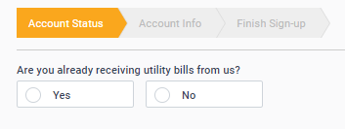
If the answer is no, you will proceed to the next screen where you can enter contact information including Phone Number, Account Type (Citizen or Business), Name, Email Address, and set a password. If you are a business, you will be asked for the business name and Federal ID.
- If you are a current Utility Customer, you must then provide additional information for your utility account:
  - Account Number. Also select whether you are a renter or own the property. If you have multiple accounts, you only need to enter one here and the additional accounts can be added later.
  - Current Physical Address Where Service is Located. This is the Physical Address associated with the Utility Account.
  - Account Type. If you are a business, you will be asked for the business name and Federal ID.
  - Name. Enter your first and last name. Middle name is optional.
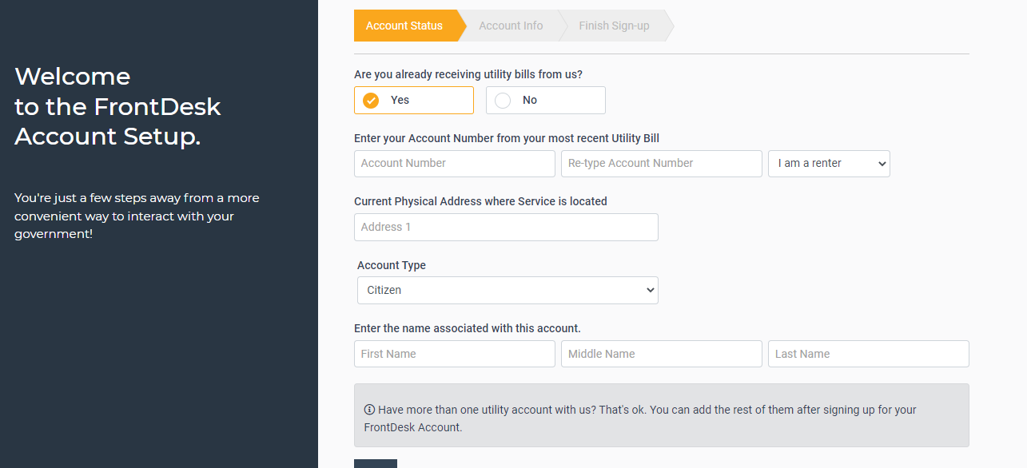
Your Account is now created!

