20th Annual “Cruisin’ into Summer” Car Show

WHEN: SATURDAY, APRIL 27, 2024
ENTRY: $20.00 – One vehicle
2023 Best of Show Car 1960 TR3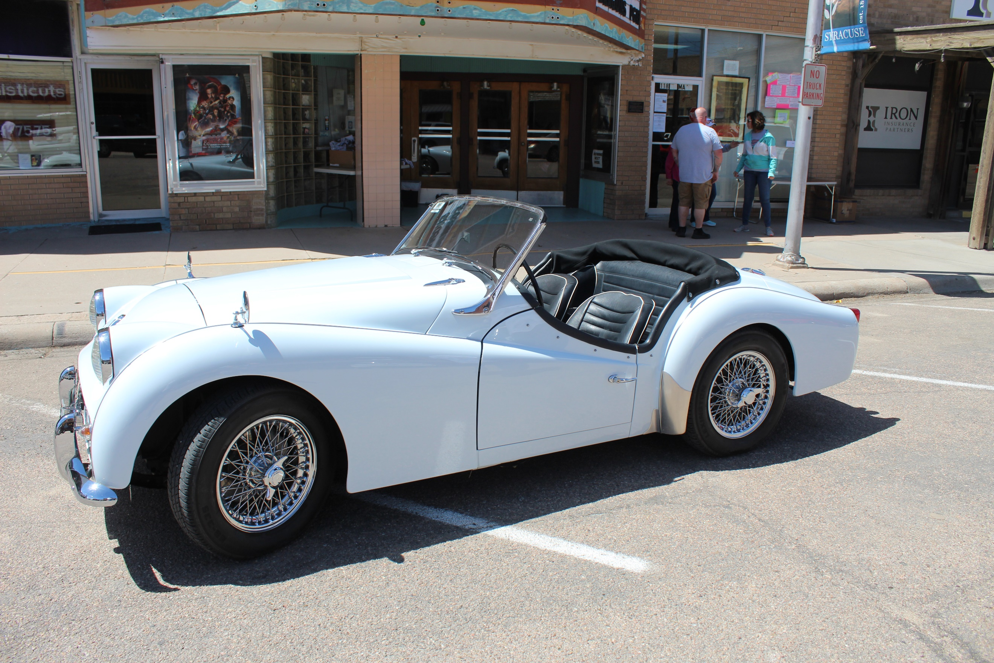
(Includes free tee shirt)
ADDITIONAL ENTRIES: $10.00 No Tee Shirt
(Tee shirt available for $8.00 with additional
Entries)
Registration 8:00-10:00am at Northrup Theatre
Prizes awarded at 1:30 pm

Grand Prize Best of Show Car
People’s Choice
And more!

WHERE: MAIN STREET, SYRACUSE, KS
- Sponsored by Syracuse-Hamilton County Chamber of Commerce & local business:
- Vendors welcome! Contact Krista Norton

